Go to cooltrebuchets.weebly.com and answer the following questions using the resources provided there.

- Where is it believed the first trebuchets were ever used?
- Up until which century were trebuchets used?
- Name to two main kinds of trebuchets and their distinguishing features.

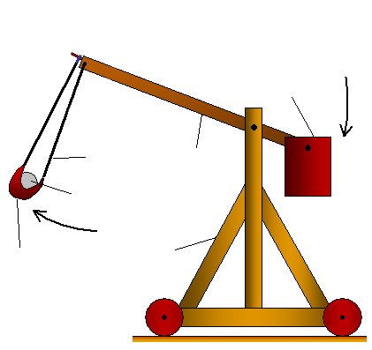
- Label the parts on this trebuchet.

- Use the link for the simulator on the “Build One!” page of the website and fill out a chart showing the different lengths, weights, and distances from the simulations to prepare making your trebuchet referring to the set guidelines (see mass of projectile, already provided). Attach the chart to this worksheet.

